# Smart Student Enrollment and learning Portal (Phase 8)

**Goal:**

The goal of this project is to build a Salesforce-based Student Enrollment and Learning Portal that automates the complete admission process. It will streamline student inquiries, course enrollments, and fee tracking while reducing manual effort and delays. Automated notifications and reminders will improve communication with students and faculty. Overall, the system will enhance efficiency, accuracy, and reporting, ensuring a smoother enrollment experience for educational institutes.

**Problem Statement:**

Educational institutes face challenges in managing student inquiries, admissions, and course enrollments due to manual processes. This causes delays, missed follow-ups, and inefficiency. A Salesforce-based portal will automate lead capture, admissions, fee tracking, and notifications, ensuring faster enrollment and better reporting.

# Phase 8: Data Management & Deployment

Phase 8 focuses on **Data Management and Deployment**, ensuring that data is imported, secured, and maintained properly, while also preparing the system for deployment from sandbox to production. This phase helped establish data integrity and a smooth transition into a production-ready environment.

## ****Data Import & Migration****

* Imported **Student and Course data** using **Data Loader**.
* Migrated existing admission records into the portal to ensure continuity.
* Verified data consistency after import to avoid duplication and errors.

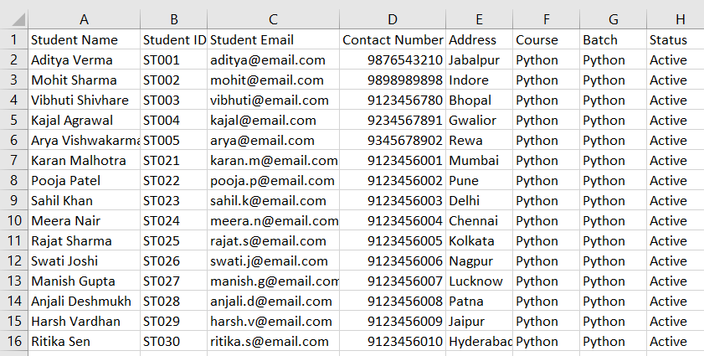

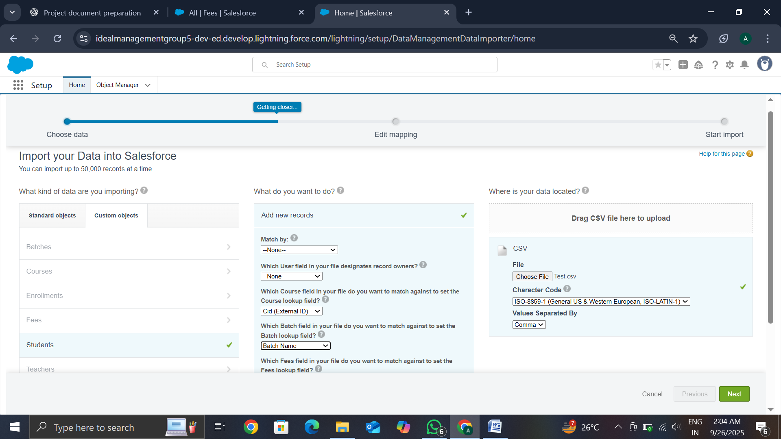

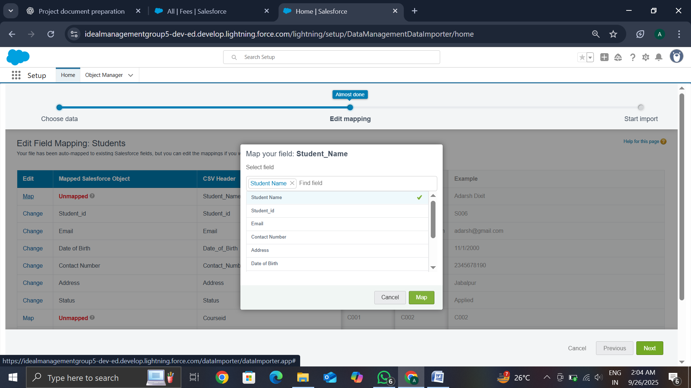

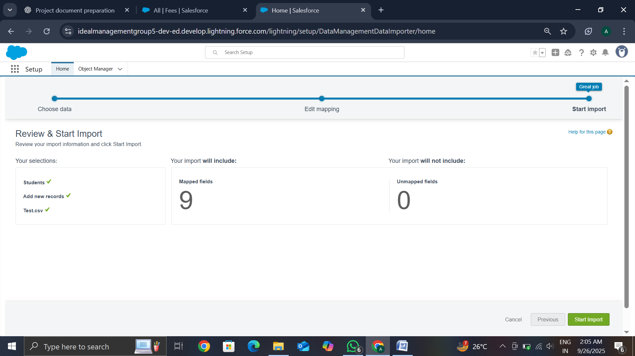

## ****Duplicate Management****

* Defined **Duplicate Rules** to prevent multiple admissions for the same student.
* Implemented matching criteria based on **Student Email** and **Student ID**.
* Reduced errors caused by duplicate records in the system..

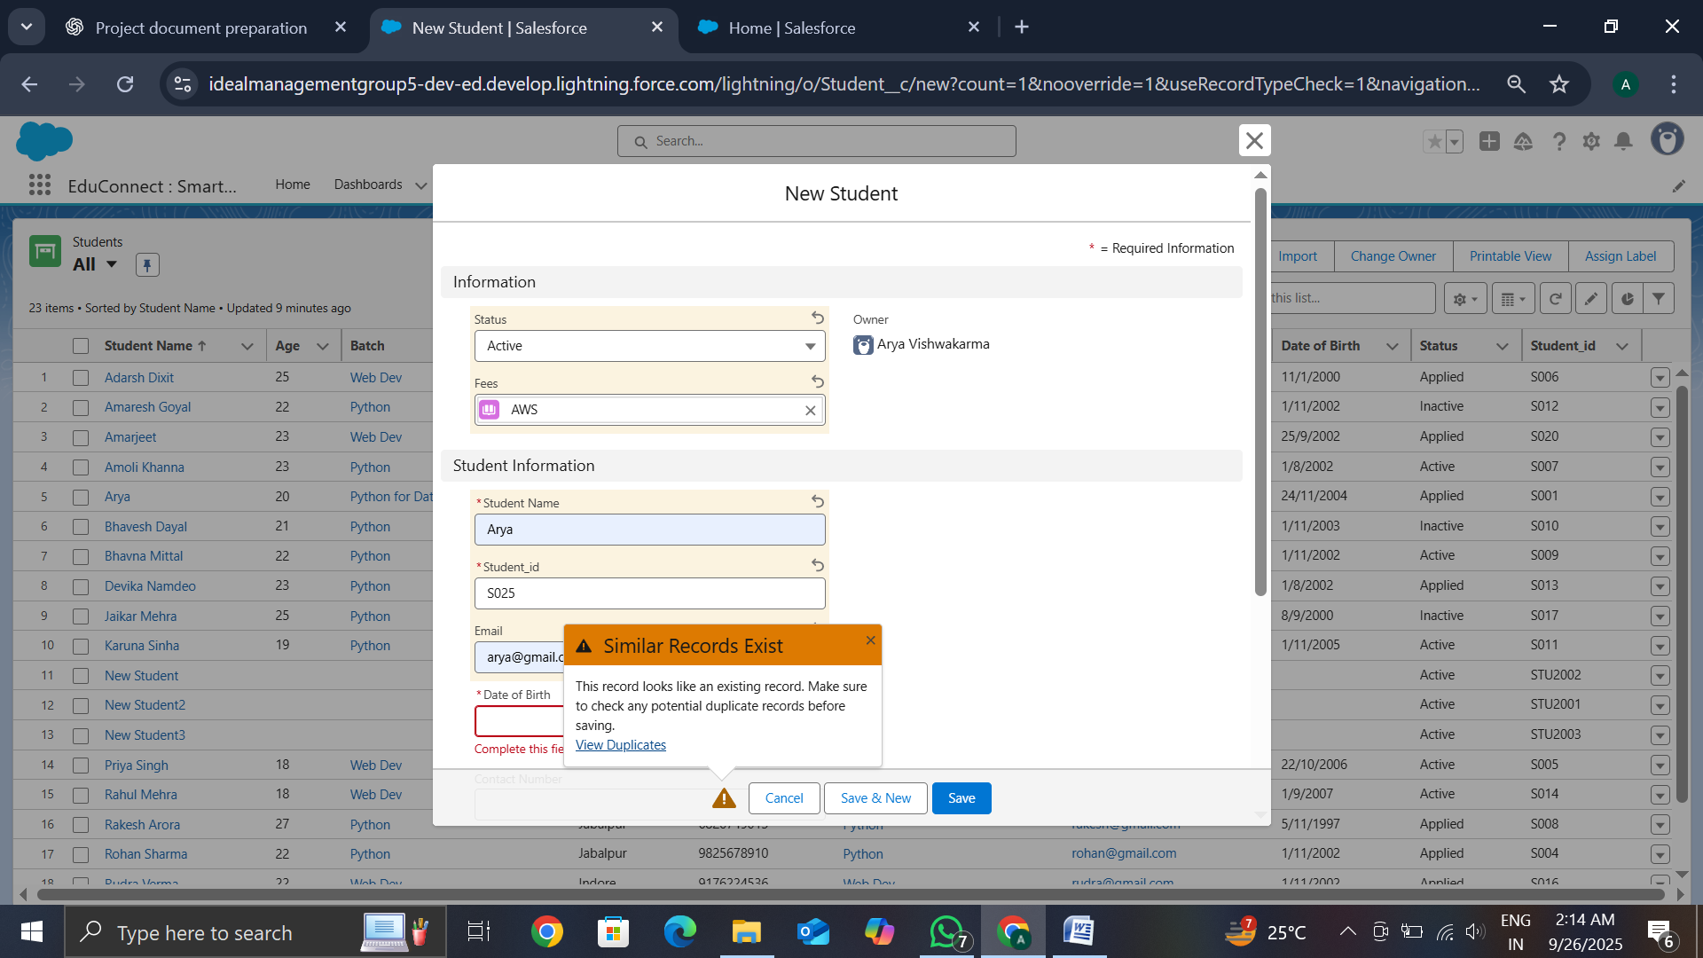

## ****Conclusion****

Phase 8 ensured proper **data management and deployment practices**. With data import, duplicate prevention, scheduled backups, and safe deployment, the system was made **reliable, secure, and production-ready**, laying a strong foundation for long-term sustainability.